**Tutorial 1: Review Object Oriented Programming concepts**

**(*) You should follow instructor’s guideline to complete tutorial in correct format. Write your answer in section “Your answer goes here”. In this section, font set to “Times new roman”, with normal font, code example MUST BE in Courier New.**

**Part 2: Practice exercises**

**From this part onwards, you are required to program based on requirements below. Since it’s the first tutorial, work in group of 3 or less is required. You are free to choose your preferred IDE to finish tasks.**

**Req 1:** a. Create a class called Car. The Car class has the following fields and methods.

* int speed;
* Double regularPrice;
* String color;
* String carName 🡺 not in constructor, but in setter method.
* Double getSalePrice(). Assume if color is “Black”, then sale price is equal to “Regular price * 1.5”, else equal “Regular price * 1.2”

**Req 2**: Create instance of class Car, named “Mondeo” with following value, using constructor to initialize object of class

**Speed = 80**

**regularPrice = 5000**

**color = red**

Print to screen car information, such as “**Mondeo** car whose speed is **80**, color **Red** with regular price = **5000** and sale price = **6000**”

**Req 3**: Create instance of Car, named “Camry” with following value, using constructor to initialize object of class

**Speed = 90**

**regularPrice = 6000**

**color = black**

Print to screen car information, such as “**Camry** car whose speed is **80**, color **Black** with regular price = **6000** and sale price = **9000**”

**Req 4: This is new requirement, it’s not related to previous exercise.**

Create class **Student** and **Course** including these attributes, write getters and setters methods if necessary for these attributes of each class.

Student:

+ String studentId

+ String studentName

Course:

+ String courseCode

+ String courseName

And create Enrolment class, which contain information of student and courses with corresponding marks. Attributes of Enrolment class include

+ Student student

+ Course course

+ int attendanceMark

+ float midtermMark

+ float finalMark

Initiate 3 students and 3 courses with attribute values of your choice, and assign Student to courses with attendance mark, midterm and final mark of your choice. Finally print out report as follow

“Student <name> whose id is <studentId>, enrol in Course <name> got attendance mark = <attendance mark>, midterm = <midterm> and final = <final>. Overall is <overall>”.

(*) Note: Overall = (attendance * 1 + midterm * 3 + final * 6)/10

Answer

1+2+3 Class Car

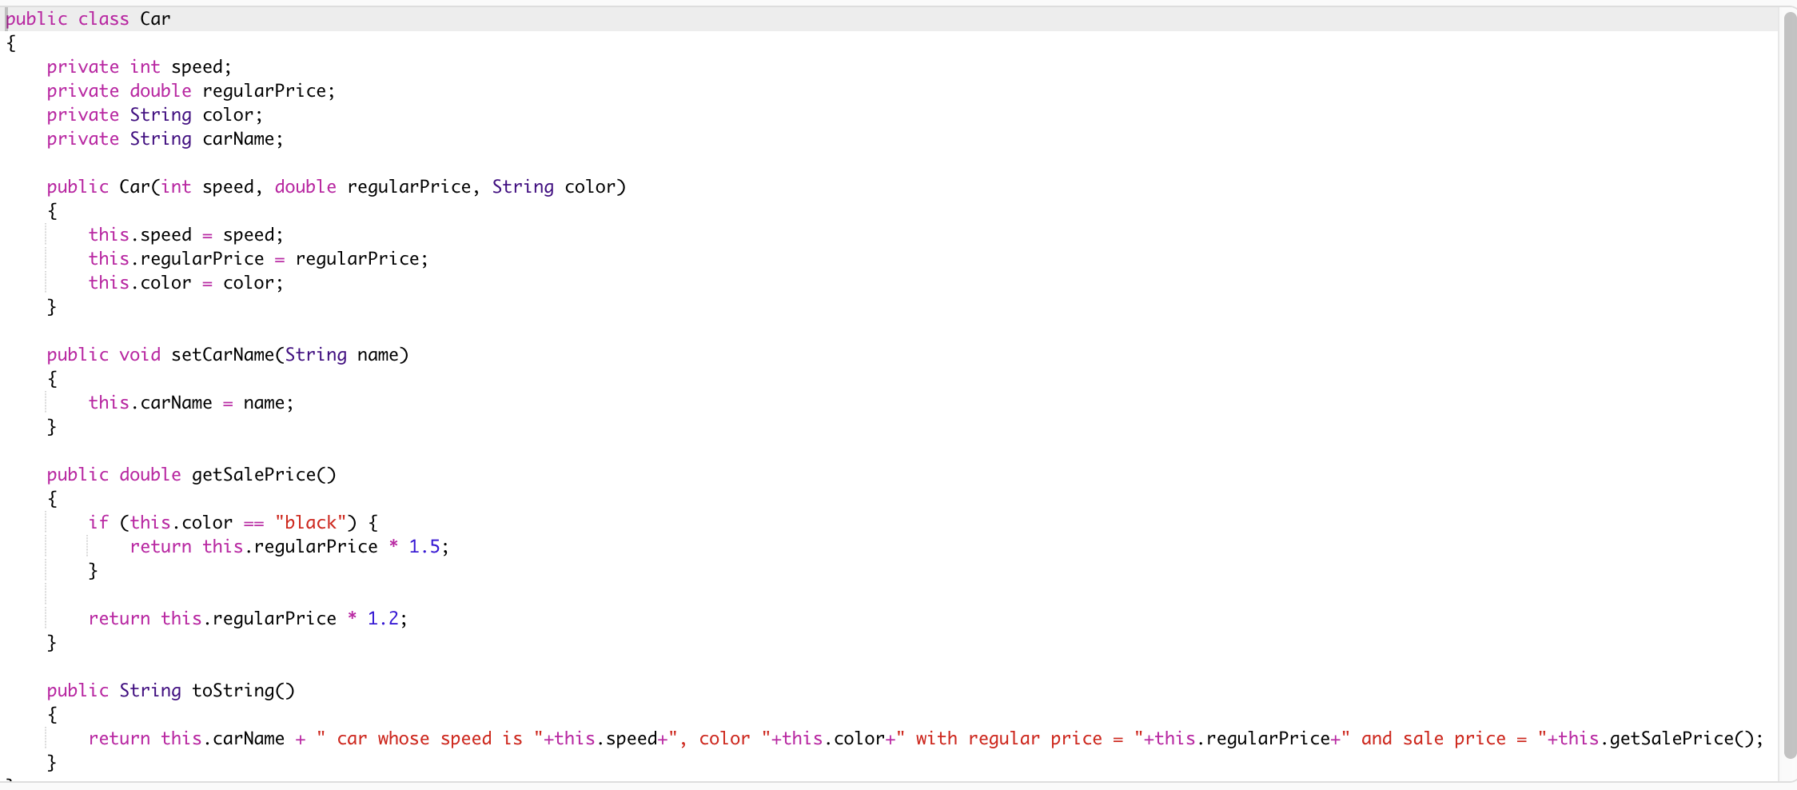

Main

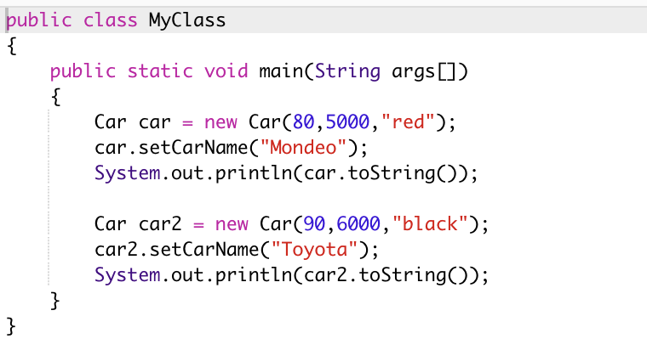

Req 4

